**Practical 4**

**Q. Write a PHP script to check whether given year is leap year or not.**

**Code:**

<htm>

<body>

<head>

<title>Leap Year</title>

</head>

<form method="POST">

Number:<br>

<input type="text" name="num" placeholder="Enter Number"/><br>

<input type="submit" name="submit" value="Check Leap Year"/><br>

</form>

<?php

if(isset($_POST['submit']))

{

$a= $_POST['num'];

if($a%400==0)

{

echo"$a is Leap Year";

}

else if($a%100==0)

{

echo"$a is Not Leap Year";

}

else if($a%4==0)

{

echo"$a is Leap Year";

}

else

{

echo"$a is Not Leap Year";

}

return 0;

}

?>

</body>

</html

**Output:**

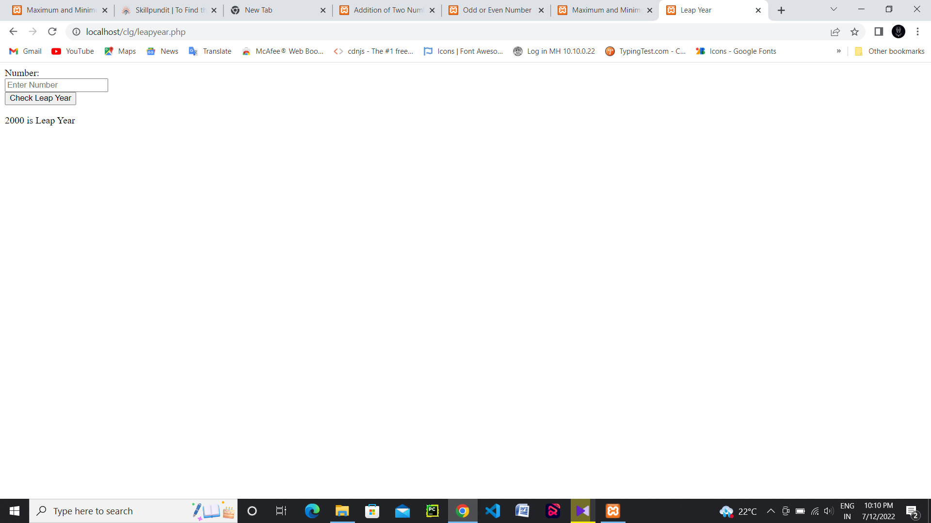

Top of Form